Click on manage Jenkins

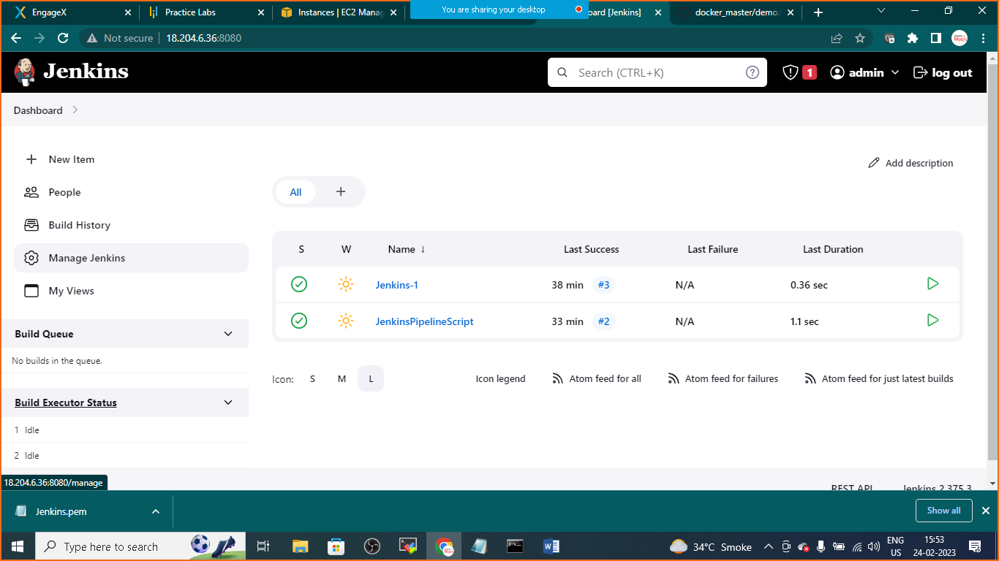

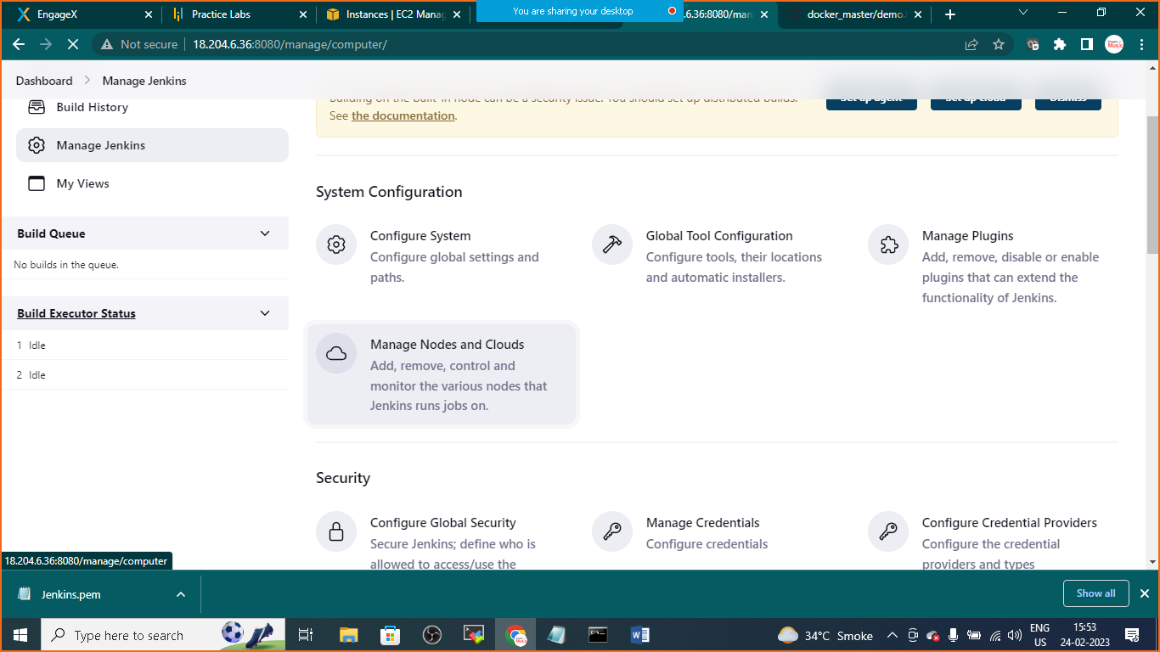

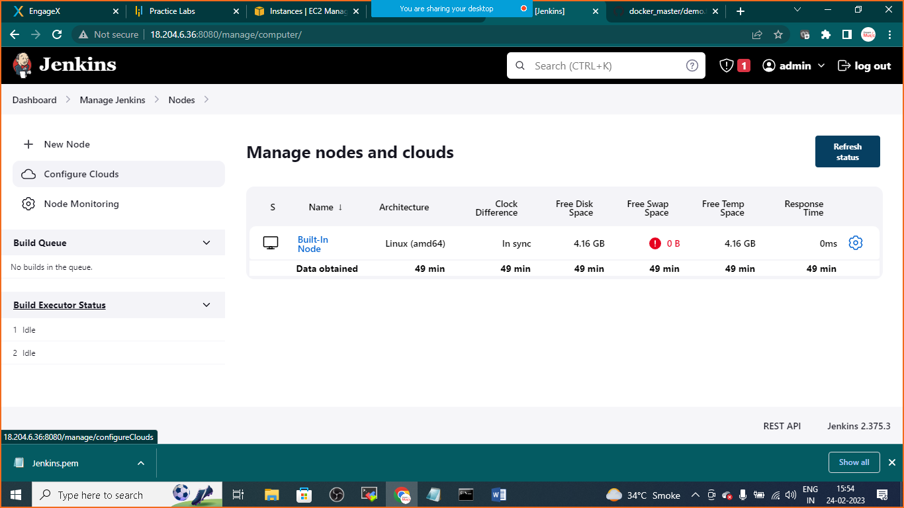

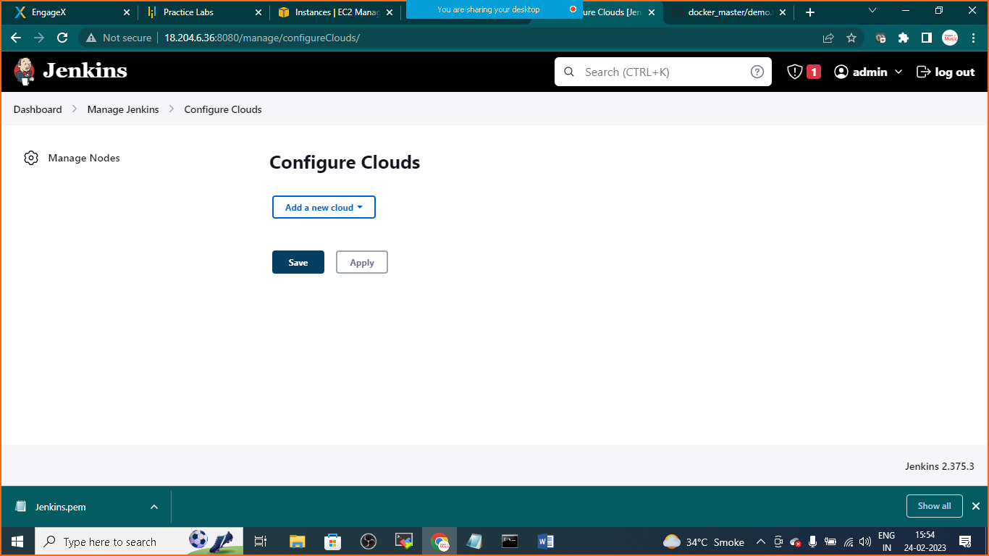

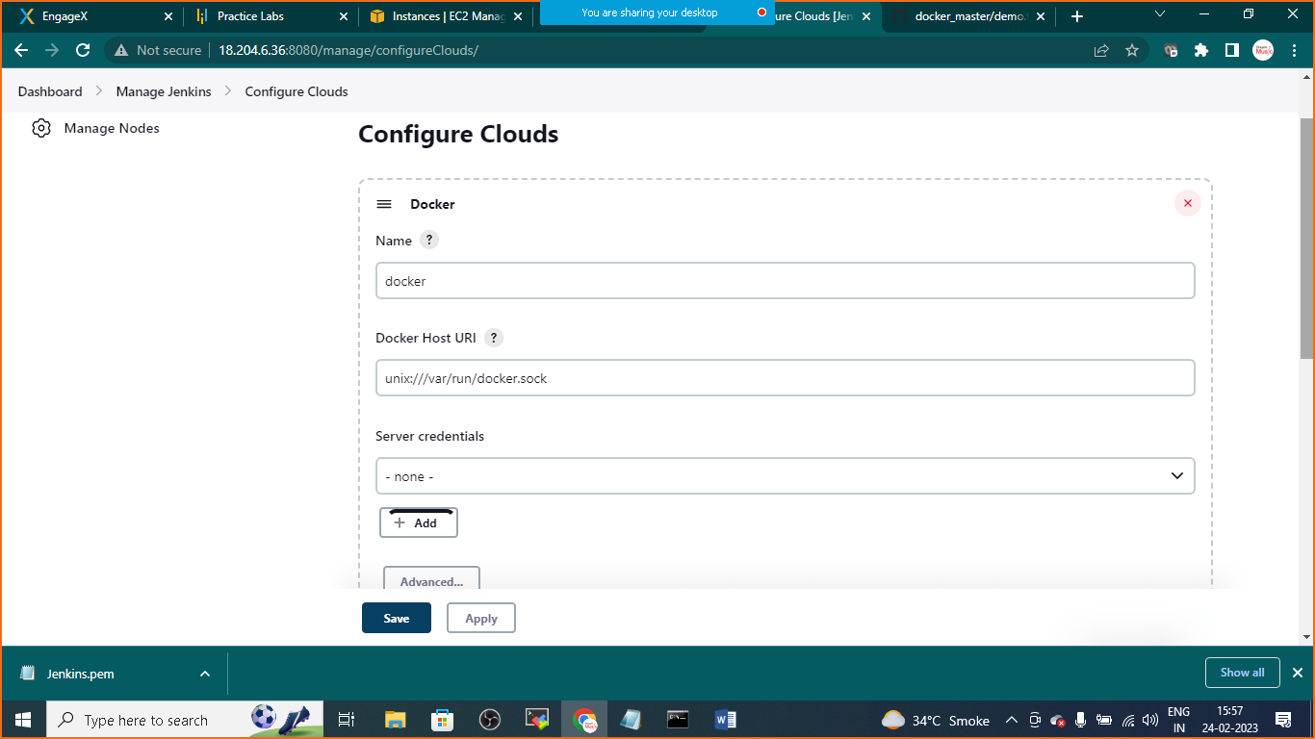

HOST URI:

Unix:///var/run/docker.sock

Click on test connection

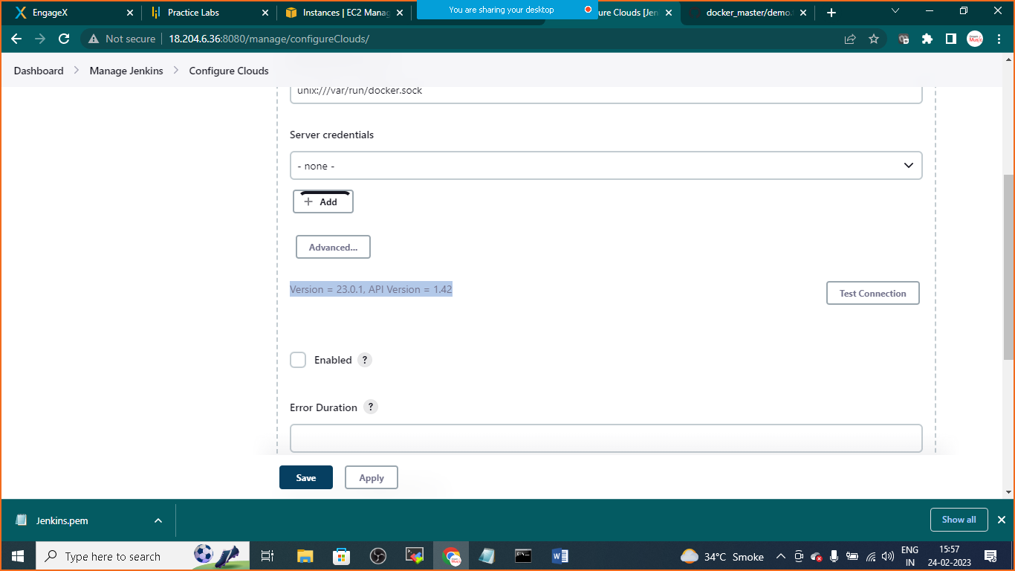

You will get version

Click on apply and save

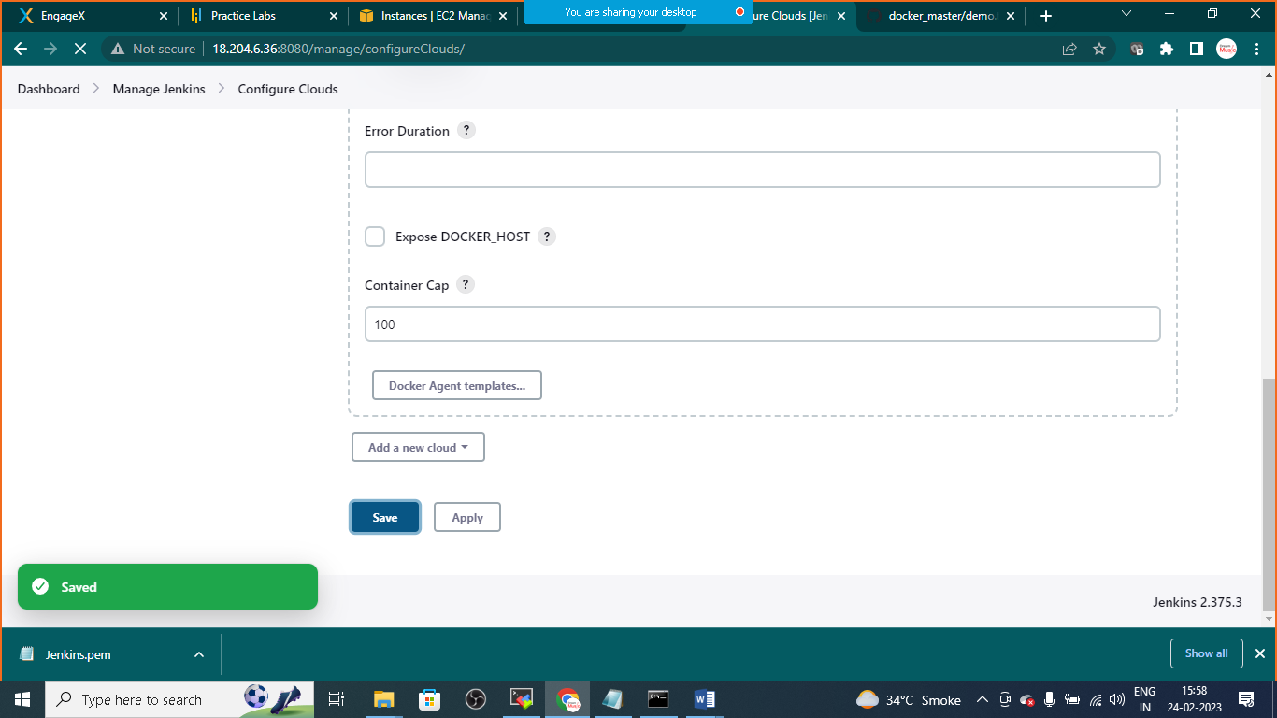

Goto>dashboard> create new freestyle project>

Give the name: JenkinsPipeline Project

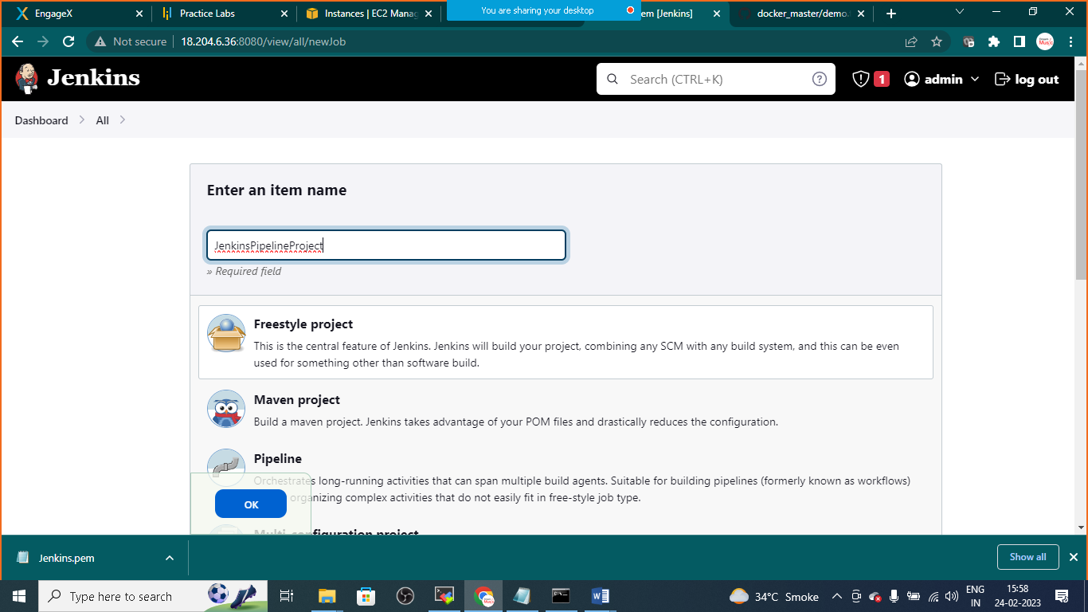

In sourcecode management provide your git hub repository link of your app

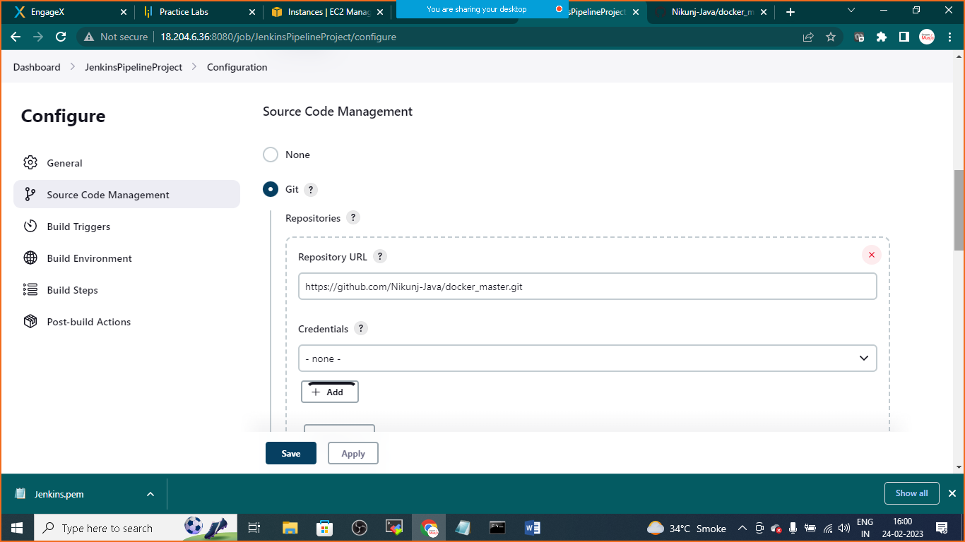

Link: <https://github.com/Nikunj-Java/docker_master.git>

In build triggers:

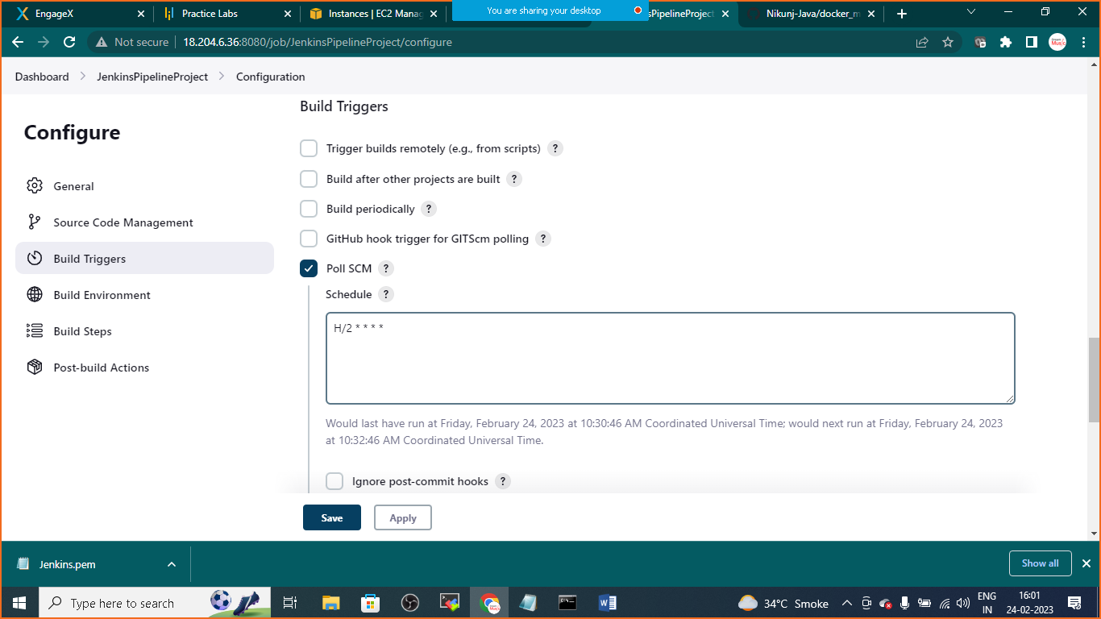

Choose poll SCM

In schedule: H/2 * * * *

Build Environment

Choose Build/Publish Docker image

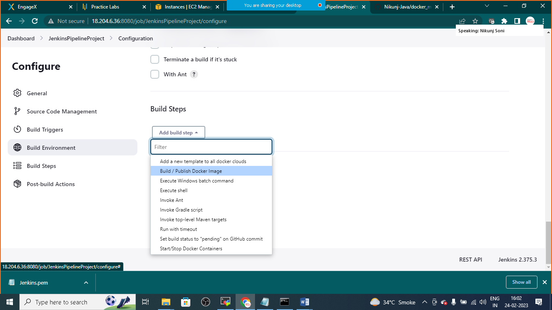

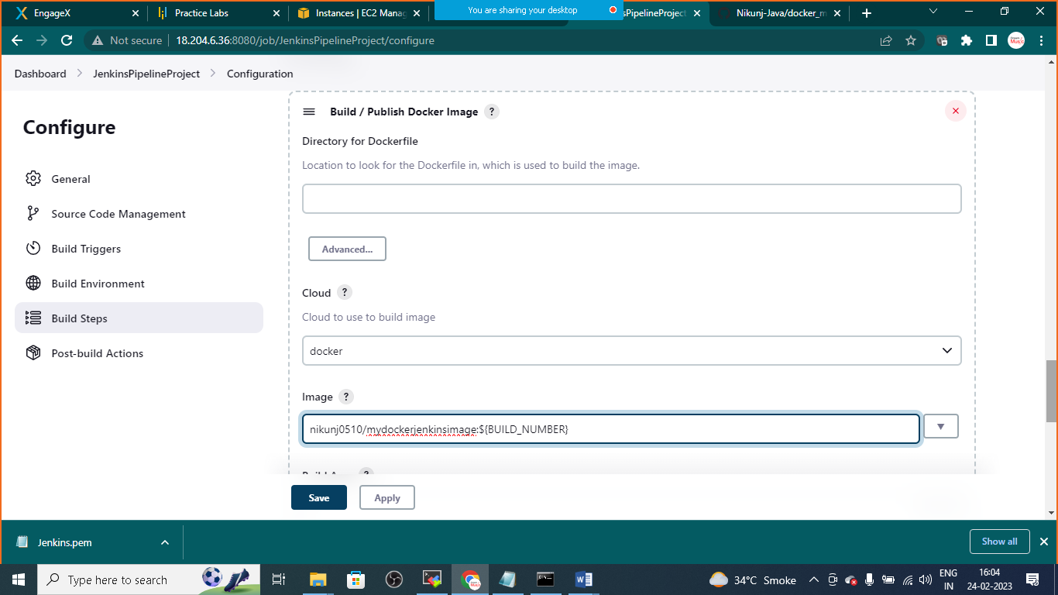

In image: nikunj0510/mydockerjenkinsimage:${BUILD_NUMBER}

<yourdockerhubusername>/<yourimagename>:${BUILD_NUMBER}

Click on push images

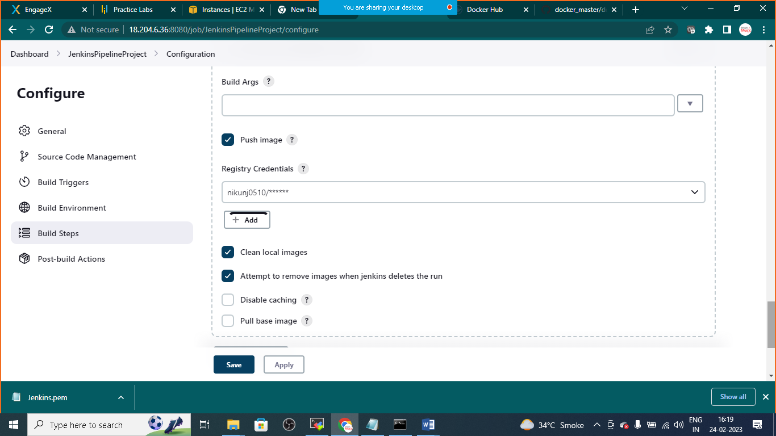

Provide your DockerHub Userid and Password in Registry Crendetials

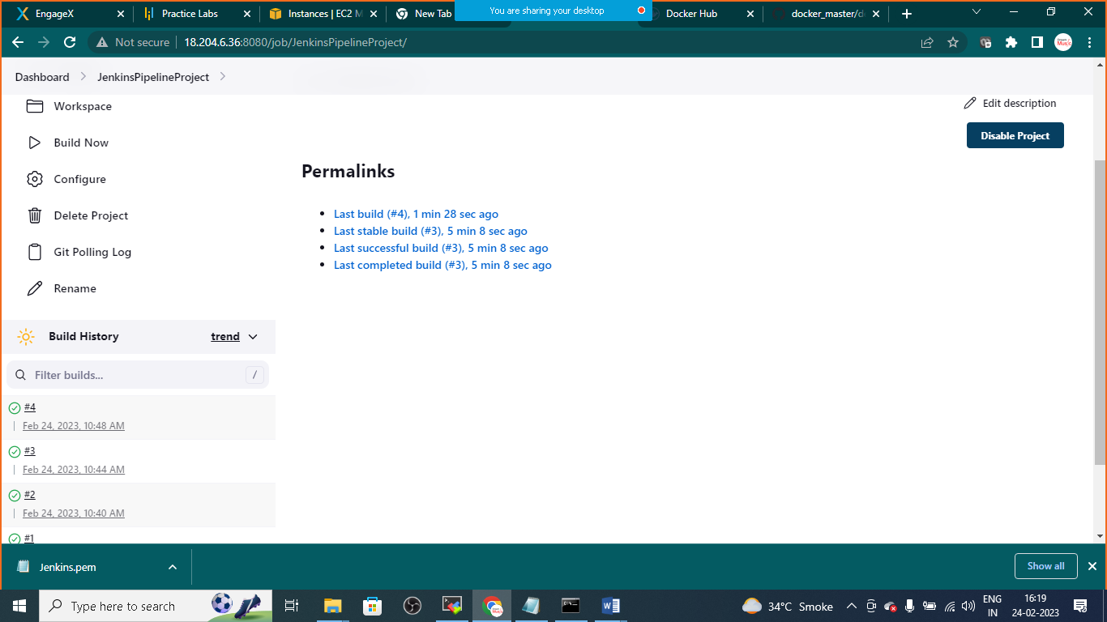

Once the build is completed

Open Dockerhub and check the image deployed

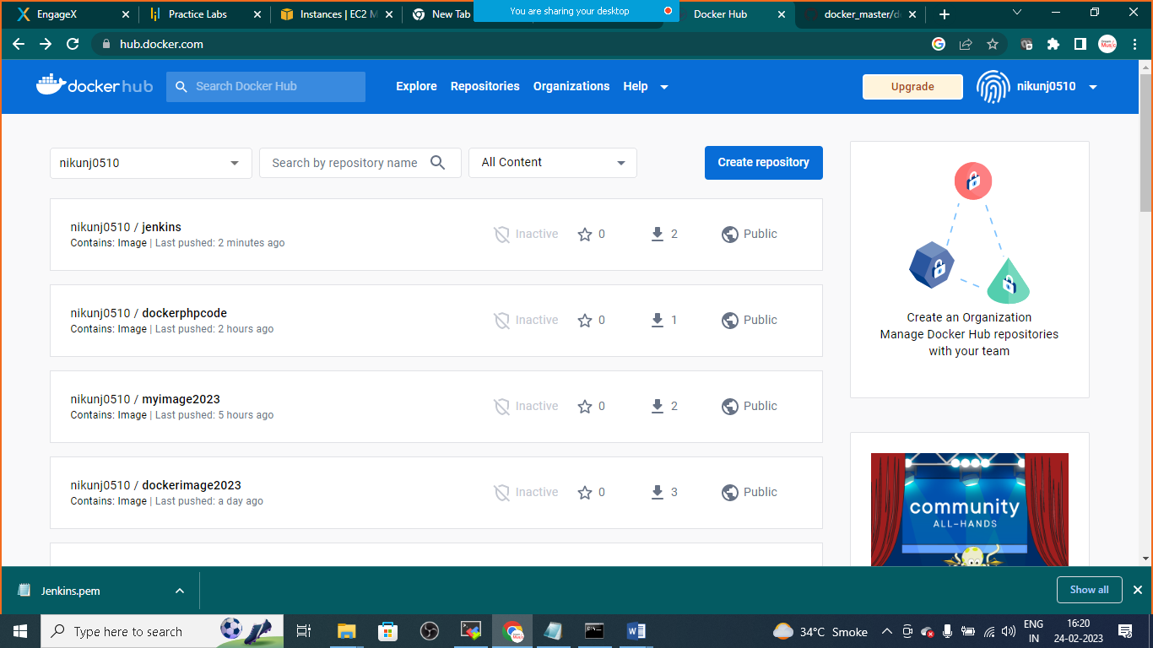

Now further any changes on git hub will prepare and deploy app on docker hub repository